**OBJECT ORIENTED ANALYSIS AND DESIGN**

**DIGITAL ASSIGNMENT- 1**

**Name: GARLAPATI SAITEJA**

**Reg. no: 17BIT0217**

**Slot: B2**

1. Collaboration Diagram

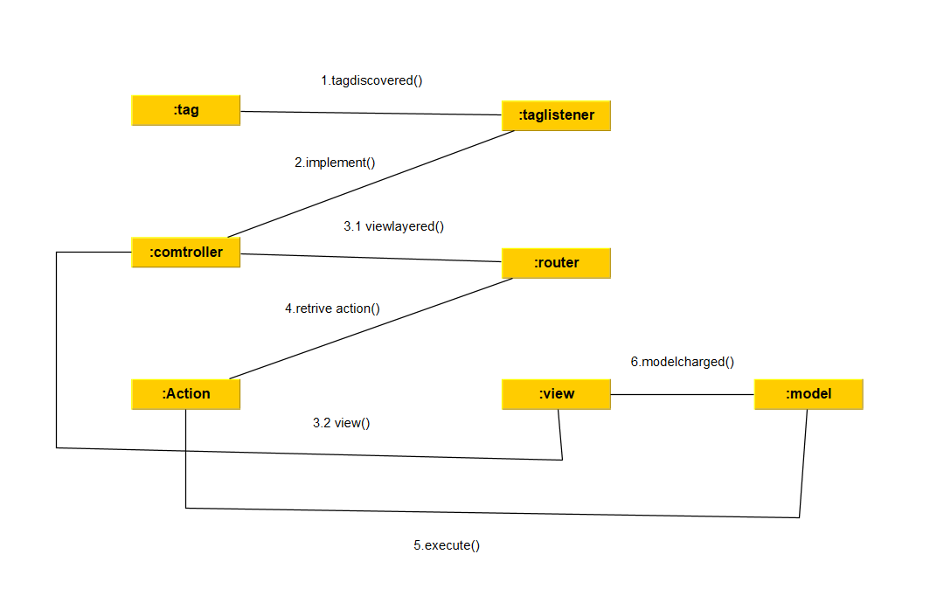

1. Object Diagram

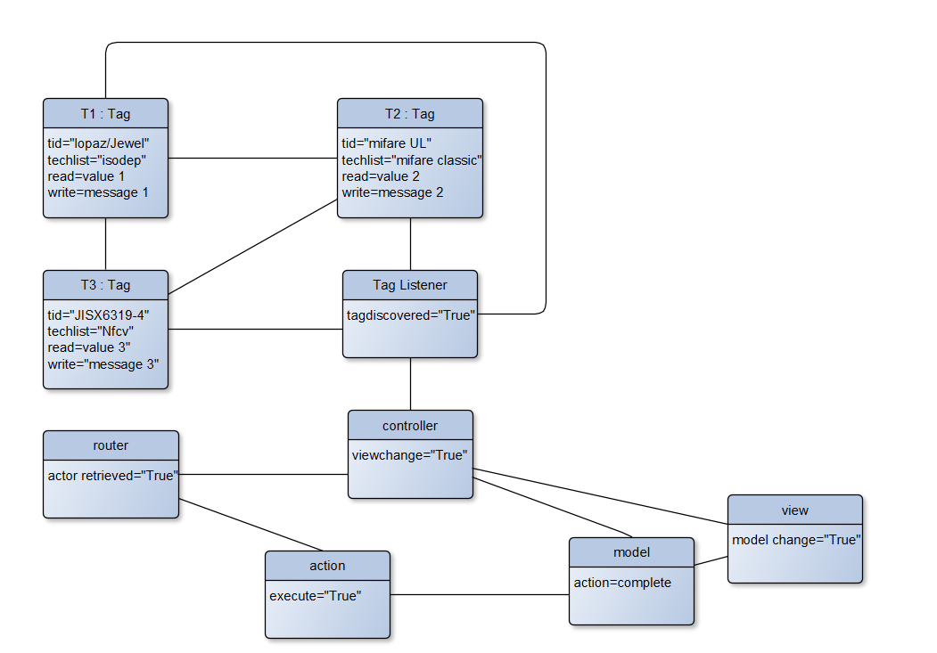

1. Requirement Workflow

Scenario:

Bob checks into a hotel. The registration desk has a NFC terminal at which keys to access Bob’s room can be transferred to his phone. Bob has a “My keys” webapp which manages his NFC keys. Bob uses his webapp to collect his keys from the NFC terminal, through the NFC hardware on his phone. Later, Bob uses the “My keys” webapp to unlock his room door and open the minibar.

Step 1: Bob checks into a hotel.

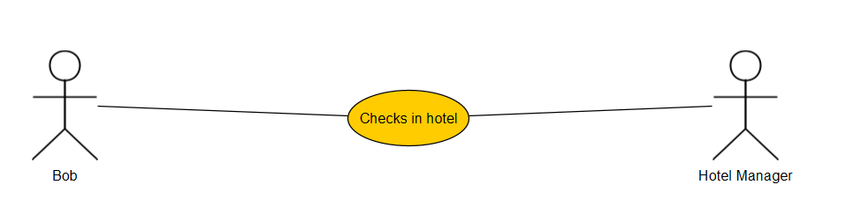

Step 2: Bob downloads the “My keys” webapp on his phone and registers in it.

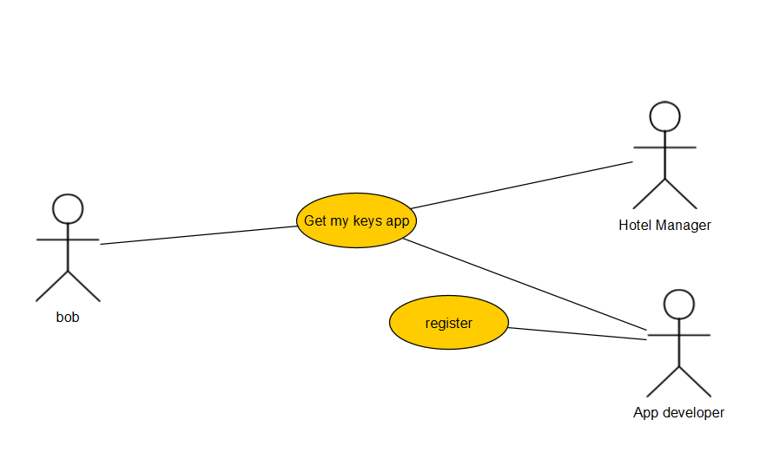

Step 3: Bob connects to the NFC on his phone and to the android beam. It discovers NFC tag and verifies it. Now he connects it to the hotel’s NFC terminal and gets the access to his room key.

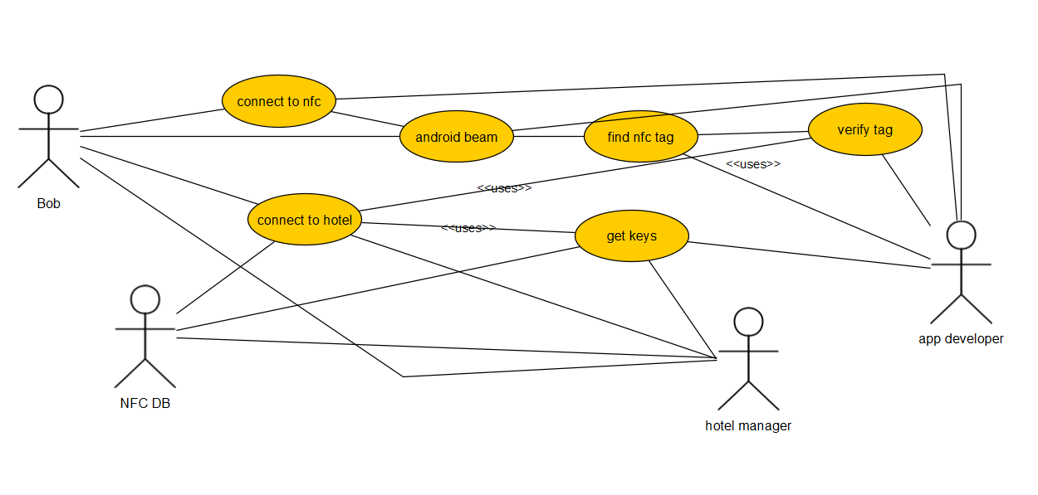

Step 4: Bob now connects to the lock and opens the door and the minibar.

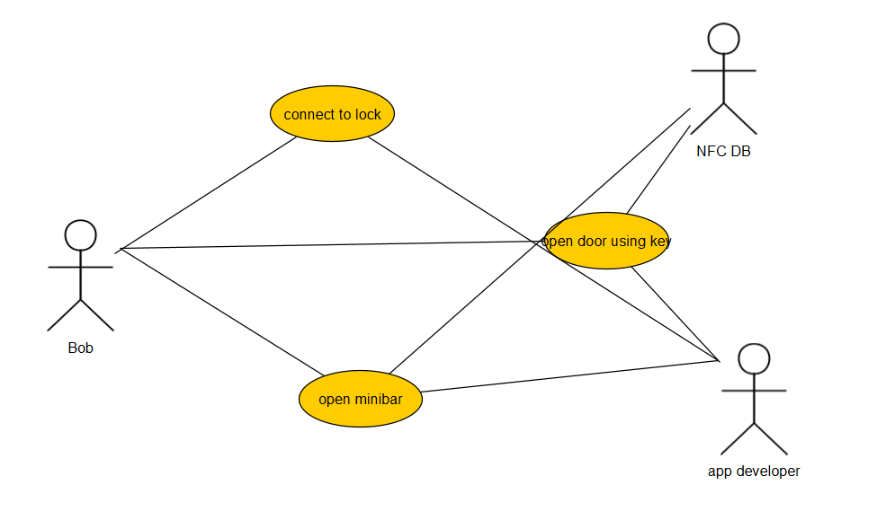

Complete Use Case Diagram for the above scenario

